## Computer Networks

## Lab Assignment Documentation

Revanoori Geethika

RA2211026050036

CSE – AIML – A

Lab 1: Introduction to Packet Tracer, Peer-to-Peer Communication, Study of Cables and its Color codes.

Procedure:

1. Open Packet Tracer:

• Launch Cisco Packet Tracer on your computer.

• Familiarize yourself with the interface, including the workspace, device selection, and tools.

1. Create a Simple Network:

• Drag two computers (PC-PT) onto the workspace.

• Drag a switch (Switch-PT) onto the workspace.

• Connect each computer to the switch using straight-through Ethernet • cables.

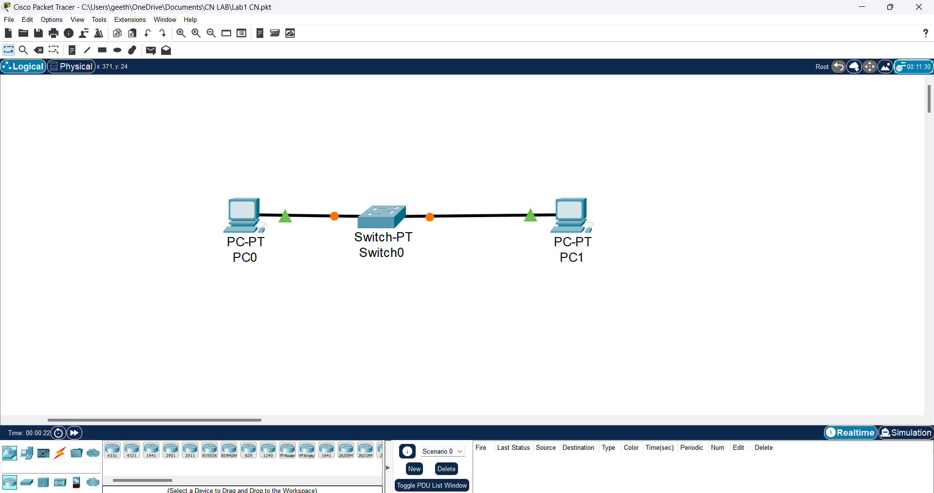

3. Configure IP Addresses:

■ Click on the first computer, go to the Desktop tab, and select IP Configuration.

■ Assign an IP address (e.g., 192.168.1.1) and a subnet mask (e.g., 255.255.255.0).

■ Click on the second computer, go to the Desktop tab, and select IP Configuration.

■ Assign an IP address (e.g., 192.168.1.2) and a subnet mask (e.g., 255.255.255.0).

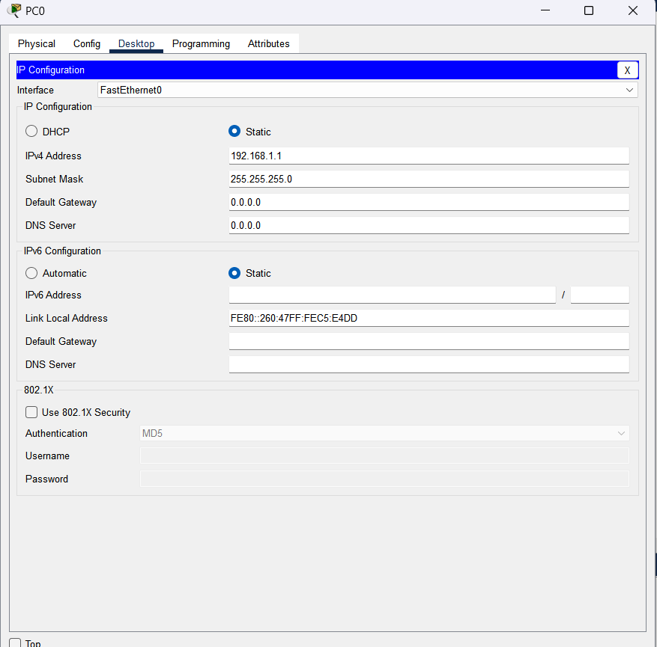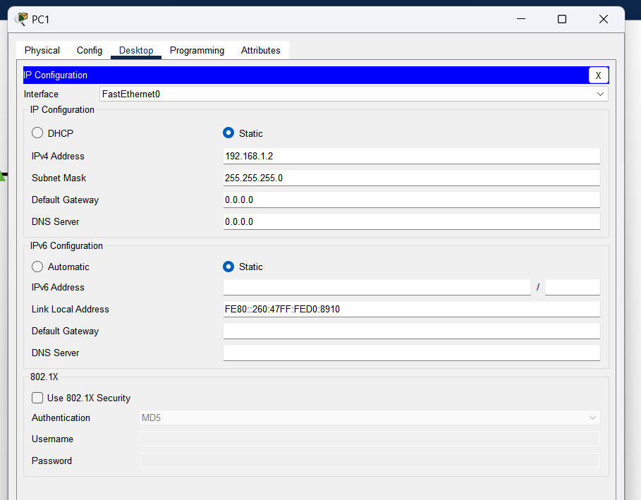

4. Test Peer-to-Peer Communication:

■ On the first computer, open the Command Prompt from the Desktop tab. ■ Use the ping command to test connectivity to the second computer (e.g., ping 192.168.1.2).

■ Observe the response to ensure the computers can communicate.

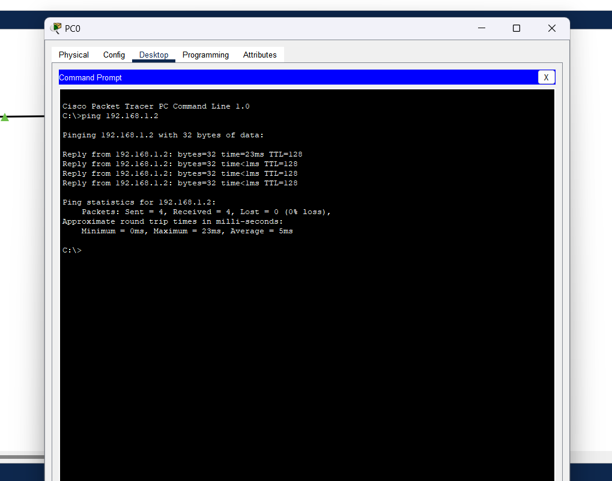

5. Study Cables and Color Codes:

■ Examine different types of network cables provided (Ethernet, crossover)

1. Ethernet Cables (Straight-Through Cables)

Ethernet cables are used to connect different devices like computers to switches or routers. These are the most common types of network cables used in LAN (Local Area Network) environments.

Color Coding (TIA/EIA-568B Standard)

Ethernet cables use a specific color-coding standard known as TIA/EIA-568B (most common) or TIA/EIA-568A.

Below is the color sequence for TIA/EIA-568B:

Pin 1: Orange/White

Pin 2: Orange

Pin 3: Green/White

Pin 4: Blue

Pin 5: Blue/White

Pin 6: Green

Pin 7: Brown/White

Pin 8: Brown

The TIA/EIA-568A standard switches the green and orange pairs.

Use Cases:

PC to Switch/Hub

Router to Switch

2. Crossover Cables

Crossover cables are used to connect similar devices directly, such as connecting two computers or two switches together without the need for a hub or switch in between.

Color Coding (TIA/EIA-568B to TIA/EIA-568A)

A crossover cable has TIA/EIA-568B at one end and TIA/EIA-568A at the other end.

End 1 (TIA/EIA-568B):

Pin 1: Orange/White

Pin 2: Orange

Pin 3: Green/White

Pin 4: Blue

Pin 5: Blue/White

Pin 6: Green

Pin 7: Brown/White

Pin 8: Brown

End 2 (TIA/EIA-568A):

Pin 1: Green/White

Pin 2: Green

Pin 3: Orange/White

Pin 4: Blue

Pin 5: Blue/White

Pin 6: Orange

Pin 7: Brown/White

Pin 8: Brown

Use Cases:

PC to PC

Switch to Switch

Router to Router